ENEZA Data Science Residential Training (cohort 3)
6th July 2026 – 7th August 2026

Project 5: CLINICAL TEXT MINING

Members:
- Godwin Mutai
- Simon Kimanzi
- George Obanda
- Clement Nyiro

Contents
1. Introduction 1
2. Problem Statement 2
3. Objectives of the Project 2
3.1 General Objective 3
3.2 Specific Objectives 3
4. Dataset Description 5
4.1 Dataset Source 5
4.2 Dataset Characteristics 5
4.3 Dataset Challenges 5
4.4 Classification Pathways 7
4.5 Dataset Suitability 8
5. Methodology 8
5.1 Research Design 8
5.2 Data Preprocessing 8
5.3 Feature Representation 9
5.4 Machine Learning Classification Models 9
5.5 Hyperparameter Optimization 10
5.6 Model Evaluation 10
5.7 Dimensionality Reduction and Visualization 11
6. Results and Discussion 12
6.1 Dataset Exploration 12
6.2 Model Performance Comparison 12
6.3 Feature Space Visualization 12
6.4 Evaluation of the Best Performing Model 13
6.5 Discussion of Findings 15
7. Limitations of the Project 15
8. Conclusion and Future Work 16

1. Introduction
The healthcare sector generates vast amounts of textual data every day through electronic health records (EHRs), clinical notes, discharge summaries, consultation reports, and patient encounter transcripts. These unstructured clinical texts contain valuable information regarding patients' symptoms, diagnoses, treatments, and clinical decisions. However, extracting meaningful knowledge from free-text medical records remains a significant challenge due to the complexity of medical terminology, abbreviations, and the diverse writing styles of healthcare professionals. As healthcare institutions continue to digitize their operations, there is an increasing demand for automated techniques that can efficiently analyze and interpret clinical text.
Clinical text mining is a branch of Natural Language Processing (NLP) that focuses on extracting useful information from unstructured medical documents. By combining computational linguistics, machine learning, and statistical techniques, clinical text mining enables healthcare systems to transform narrative medical records into structured information that can support clinical decision-making, disease surveillance, medical research, and hospital management. Recent advances in machine learning have further improved the ability to classify, summarize, and interpret large collections of clinical documents, making automated clinical text analysis an increasingly important area of research.
One important application of clinical text mining is the automatic prediction of medical specialties from patient consultation transcripts. Correctly identifying the appropriate medical specialty based solely on a patient's clinical narrative can support hospital triage systems, improve referral processes, reduce administrative workload, and facilitate faster access to specialist care. Such systems may also assist healthcare providers in organizing large collections of historical medical records according to specialty, thereby improving information retrieval and clinical research.
This project investigates the application of classical machine learning techniques for clinical text classification using the publicly available MTSamples clinical transcription dataset. The dataset consists of 4,999 de-identified patient visit transcripts spanning 40 different medical specialties. To address the challenges associated with large numbers of classes and class imbalance, two complementary classification strategies were investigated. The first strategy focused on predicting the most common medical specialties by restricting the analysis to specialties with at least 100 available transcripts. The second strategy grouped the original specialties into five broader clinical super-classes, thereby reducing classification complexity while increasing the number of training examples available for each category.
Multiple feature representation techniques were evaluated, including Term Frequency–Inverse Document Frequency (TF-IDF), Word2Vec, GloVe, FastText, and Named Entity Recognition (NER) combined with TF-IDF. These feature extraction approaches were paired with Linear Support Vector Classification (Linear SVC) and Multinomial Logistic Regression classifiers. Each model underwent systematic hyperparameter optimization using an iterative GridSearchCV procedure, and performance was evaluated using macro F1-score, precision, recall, confusion matrices, and cross-validation to provide a comprehensive assessment of classification performance.

2. Problem Statement
Healthcare facilities generate large volumes of unstructured clinical text during routine patient care, including consultation notes, medical transcripts, discharge summaries, and diagnostic reports. While these documents contain valuable clinical information, their unstructured nature makes them difficult to organize, analyze, and utilize efficiently for automated decision-making. In many healthcare settings, assigning patients to the appropriate medical specialty or organizing clinical records still relies heavily on manual review by healthcare professionals, a process that can be time-consuming, labor-intensive, and susceptible to inconsistencies.
Automatic medical specialty classification from clinical transcripts has the potential to improve clinical workflows by supporting patient triage, facilitating specialist referrals, and enhancing the management of electronic health records. However, developing an accurate classification model is challenging because clinical narratives frequently contain overlapping symptoms, shared medical terminology, abbreviations, and varying documentation styles. In addition, the distribution of medical specialties is often highly imbalanced, with some specialties represented by many more patient records than others. This imbalance can reduce the ability of machine learning models to generalize effectively across all specialty classes.
The MTSamples clinical transcription dataset used in this project contains transcripts belonging to 40 different medical specialties, many of which contain relatively few observations. Such a large number of classes, combined with severe class imbalance, increases the complexity of the classification task and may negatively affect model performance. To address these challenges, this project investigated two complementary classification strategies. The first strategy focused on predicting the most frequently occurring specialties by selecting specialties with at least 100 available transcripts. The second strategy reduced the classification complexity by grouping related specialties into five broader clinical super-classes, thereby increasing the number of training examples available for each class while sacrificing some classification granularity.

3. Objectives of the Project

3.1 General Objective
The overall objective of this project is to evaluate the effectiveness of different text representation techniques and classical machine learning algorithms for clinical specialty prediction, compare fine-grained and broad-category classification strategies, and identify the most suitable approach for clinical text classification within the constraints of traditional machine learning methods. The findings provide insights into the strengths and limitations of conventional NLP techniques for healthcare applications and establish a baseline for future research involving transformer-based language models and other deep learning approaches for clinical text mining.

3.2 Specific Objectives
The specific objectives of the project were to:
- Acquire and preprocess the MTSamples clinical transcription dataset by cleaning the text, handling missing values, and preparing the data for machine learning analysis.
- Investigate two alternative classification strategies by:
  - predicting the most frequently occurring medical specialties using specialties with at least 100 transcripts (Path 1), and
  - reducing the original specialties into five broader clinical super-classes to minimize class imbalance (Path 2).
- Compare multiple feature representation techniques, namely TF-IDF, Word2Vec, GloVe, FastText, and Named Entity Recognition (NER) combined with TF-IDF, for representing clinical text.
- Evaluate the performance of Linear Support Vector Classification (Linear SVC) and Multinomial Logistic Regression using each feature representation method under both classification pathways.
- Optimize the performance of each model through iterative hyperparameter tuning using GridSearchCV and cross-validation based on the macro F1-score.
- Assess model performance using appropriate evaluation metrics, including precision, recall, macro F1-score, confusion matrices, and cross-validation, to identify the most effective model for clinical specialty prediction.
- Compare the effectiveness of fine-grained specialty classification and broader superclass classification in addressing class imbalance and improving predictive performance.
- Provide recommendations for future research and identify opportunities for improving clinical text classification through more advanced natural language processing techniques, including transformer-based language models.
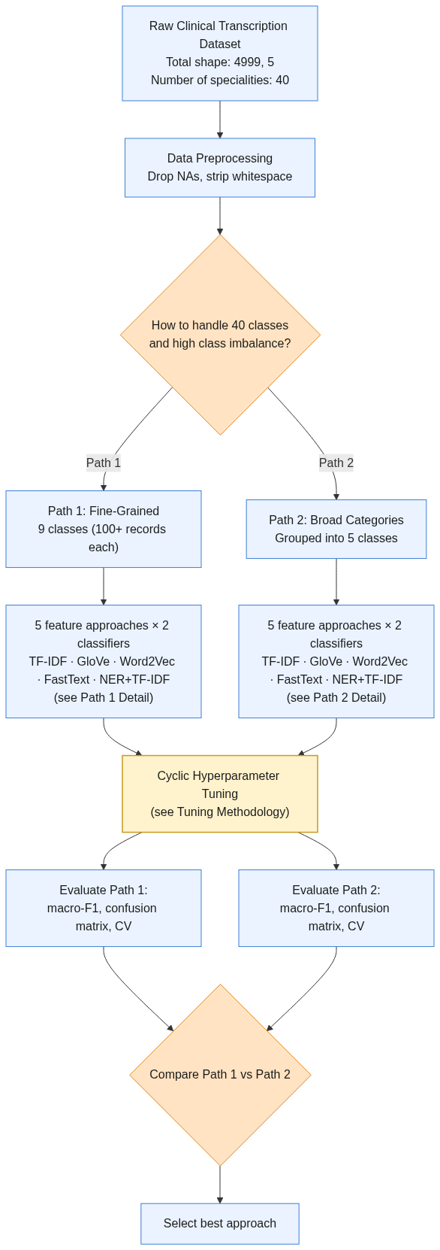

4. Dataset Description

4.1 Dataset Source
This project utilized the MTSamples clinical transcription dataset, obtained from the Hugging Face dataset repository. The dataset consists of de-identified clinical transcription records collected from real patient encounters across multiple medical specialties. Each record represents a documented clinical encounter and includes information describing the patient's condition, the consultation process, and the medical specialty responsible for patient management. The dataset was selected because it provides a diverse collection of clinical narratives spanning numerous medical disciplines, making it well suited for evaluating machine learning approaches for clinical text classification.
https://raw.githubusercontent.com/socd06/medical-nlp/master/data/mtsamples.csv

4.2 Dataset Characteristics
The original dataset contains 4,999 clinical transcription records distributed across 40 different medical specialties. Each observation contains five primary attributes describing various aspects of the patient encounter. These include:
- Description: A brief summary describing the patient's presenting condition.
- Medical Specialty: The target variable indicating the medical specialty responsible for managing the patient's condition.
- Sample Name: The type of clinical sample or procedure associated with the patient encounter.
- Transcription: A detailed narrative describing the complete patient consultation, including symptoms, examination findings, investigations, diagnoses, and treatment recommendations.
- Keywords: Important keywords extracted from the clinical transcription.
Among these variables, the transcription field served as the primary source of textual information used for feature extraction, while the medical specialty variable was used as the target class for supervised machine learning.

4.3 Dataset Challenges
Preliminary exploration of the dataset revealed two major challenges.
- The first challenge was the presence of 40 distinct medical specialties, making the classification problem highly multi-class in nature. As the number of target classes increases, distinguishing between similar specialties becomes increasingly difficult because many specialties share overlapping clinical terminology and patient symptoms.
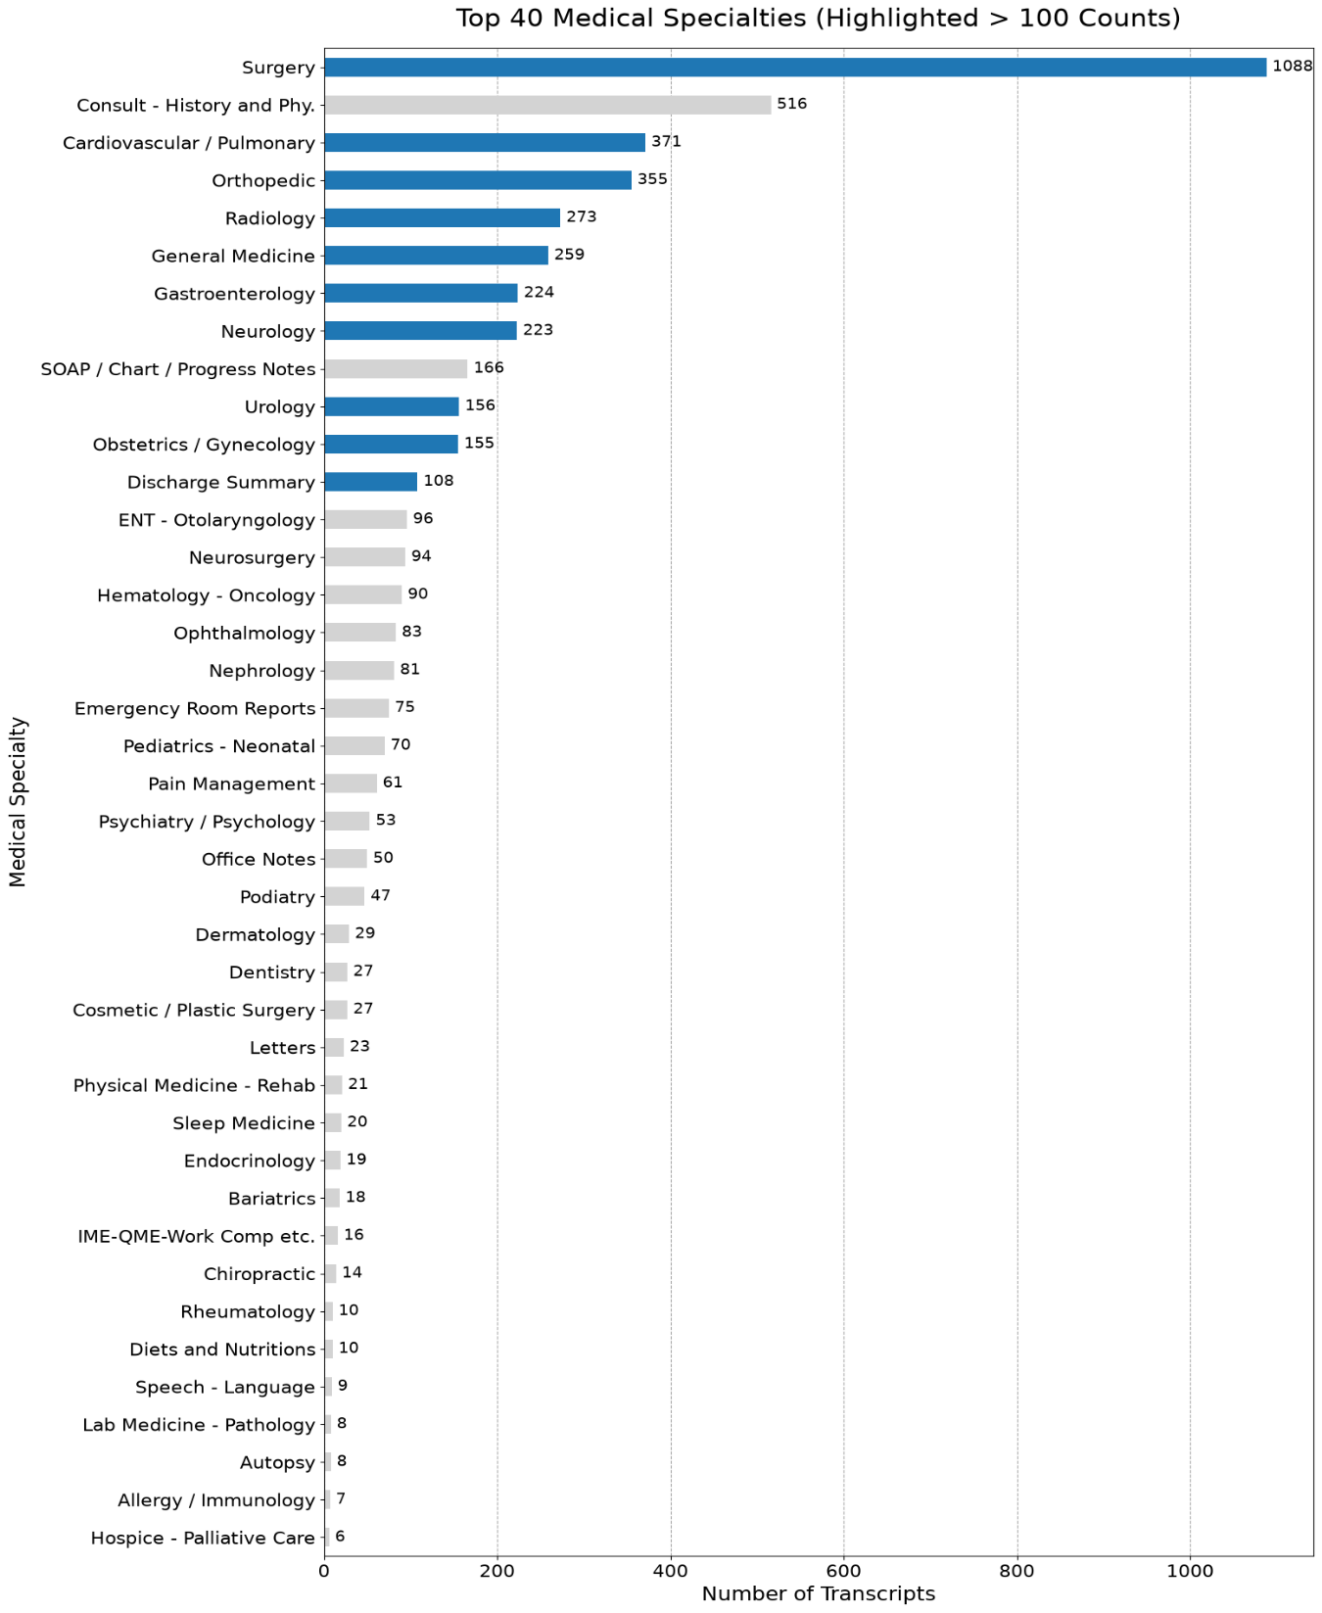
- The second challenge was class imbalance. Some specialties contained a large number of clinical transcripts, whereas many others were represented by relatively few observations. Such imbalance can bias machine learning models towards majority classes, resulting in poorer predictive performance for minority specialties. These characteristics motivated the investigation of alternative classification strategies capable of improving overall model performance.

4.4 Classification Pathways
To address the challenges associated with the dataset, two complementary classification pathways were designed.
- The first pathway retained the original medical specialty labels but restricted the analysis to specialties containing at least 100 clinical transcripts. This reduced the number of target classes to nine while preserving fine-grained specialty prediction. The objective of this pathway was to determine whether classical machine learning algorithms could accurately distinguish among the most frequently encountered medical specialties.
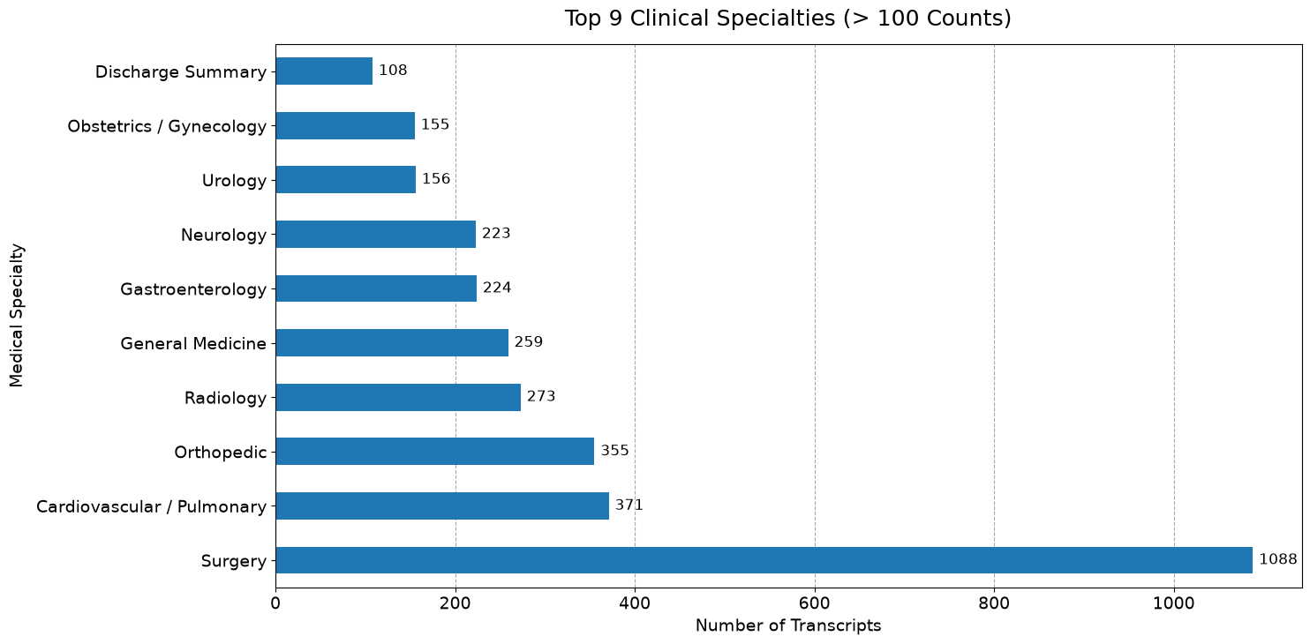
- The second pathway grouped the original 40 medical specialties into five broader clinical super-classes based on clinically related disciplines. These broader categories increased the number of training examples available within each class while reducing classification complexity. Although this approach sacrificed some specialty-level detail, it allowed the project to investigate whether broader clinical categorization could improve predictive performance by reducing class imbalance.
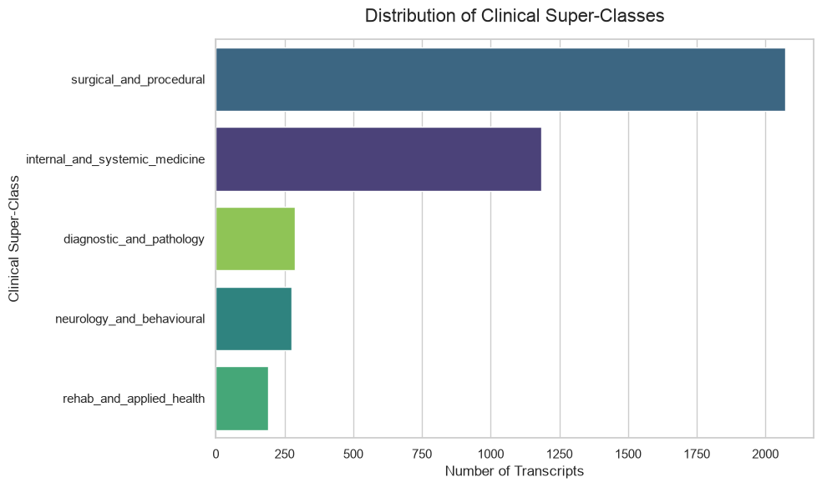

4.5 Dataset Suitability
The MTSamples dataset provided an appropriate benchmark for evaluating clinical text mining techniques because it contains realistic clinical narratives from a wide range of medical specialties. The combination of rich textual information, multiple target classes, and naturally occurring class imbalance closely reflects many real-world clinical text classification problems. Consequently, the dataset enabled a comprehensive comparison of different feature representation methods, machine learning classifiers, and classification strategies under practical healthcare conditions.

5. Methodology

5.1 Research Design
This project adopted an experimental quantitative research design to evaluate the effectiveness of different feature representation techniques and classical machine learning algorithms for clinical text classification. The experiments were conducted using supervised learning, where clinical transcription records served as the input data and the corresponding medical specialty labels were used as the target variable. The objective was to determine which combination of feature extraction method and classification algorithm produced the best predictive performance for clinical specialty classification.
The methodology consisted of a structured machine learning pipeline beginning with data preprocessing, followed by feature extraction, model training, hyperparameter optimization, model evaluation, and comparative analysis. To investigate the effect of class imbalance on classification performance, two independent classification pathways were developed.
The first pathway focused on fine-grained classification, where only medical specialties containing at least 100 clinical transcripts were retained for analysis. This reduced the number of target classes while preserving specialty-level predictions. The second pathway investigated broad-category classification, where the original medical specialties were grouped into five clinically related super-classes. This approach increased the number of training samples available within each class while reducing classification complexity. Performance from both pathways was subsequently compared to determine the trade-off between classification granularity and predictive accuracy.

5.2 Data Preprocessing
Before model development, the clinical transcripts underwent a series of preprocessing operations designed to improve text quality and prepare the data for feature extraction. Initial preprocessing involved removing records containing missing transcription values and eliminating unnecessary whitespace from the medical specialty labels. These steps ensured that only complete and consistently labelled records were included in the analysis.
The textual data were then subjected to standard natural language processing procedures. This included tokenization, stop-word removal, stemming, and lemmatization to reduce linguistic variability while preserving the semantic content of the clinical narratives. The preprocessing stage also normalized the text into a consistent representation suitable for the various feature extraction methods investigated in this project. Identical preprocessing procedures were applied across both classification pathways to ensure fair comparison between the different modelling approaches.

5.3 Feature Representation
Following preprocessing, five different feature representation techniques were investigated to transform the clinical text into numerical vectors suitable for machine learning.
The first approach employed Term Frequency–Inverse Document Frequency (TF-IDF), a statistical representation that measures the importance of words within a document relative to the entire corpus. TF-IDF served as the baseline feature extraction technique because of its simplicity, computational efficiency, and widespread use in document classification.
The second approach utilized Word2Vec, which learns dense vector representations of words based on their contextual relationships within the corpus. Unlike TF-IDF, Word2Vec captures semantic similarity between medical terms by representing words in a continuous vector space.
The third feature representation employed Global Vectors for Word Representation (GloVe). GloVe combines global word co-occurrence statistics with local contextual information to generate meaningful word embeddings capable of representing semantic relationships between medical concepts.
The fourth approach investigated FastText, an extension of Word2Vec that represents words using character-level sub word information. This enables FastText to better capture morphological similarities and handle uncommon or previously unseen medical terminology.
The final feature representation combined Named Entity Recognition (NER) with TF-IDF. In this approach, clinically relevant entities were first extracted from the transcription using spaCy's Named Entity Recognition pipeline before TF-IDF vectorization was applied to the extracted entities. This approach sought to determine whether emphasizing clinically important concepts could improve classification performance.

5.4 Machine Learning Classification Models
Each feature representation technique was evaluated using two supervised machine learning algorithms.
The first classifier was Linear Support Vector Classification (Linear SVC), which constructs an optimal separating hyperplane between classes in a high-dimensional feature space. Linear SVC has been widely applied in text classification because of its ability to perform effectively with sparse feature representations such as TF-IDF.
The second classifier was Multinomial Logistic Regression, a probabilistic linear classifier that estimates the probability of each class using the SoftMax function. Logistic Regression provides interpretable classification probabilities and has consistently demonstrated strong performance on document classification tasks involving high-dimensional text features.
Each feature representation was independently paired with both classifiers, resulting in ten model combinations for each classification pathway. Consequently, a total of twenty experimental models were trained and evaluated across the two pathways.

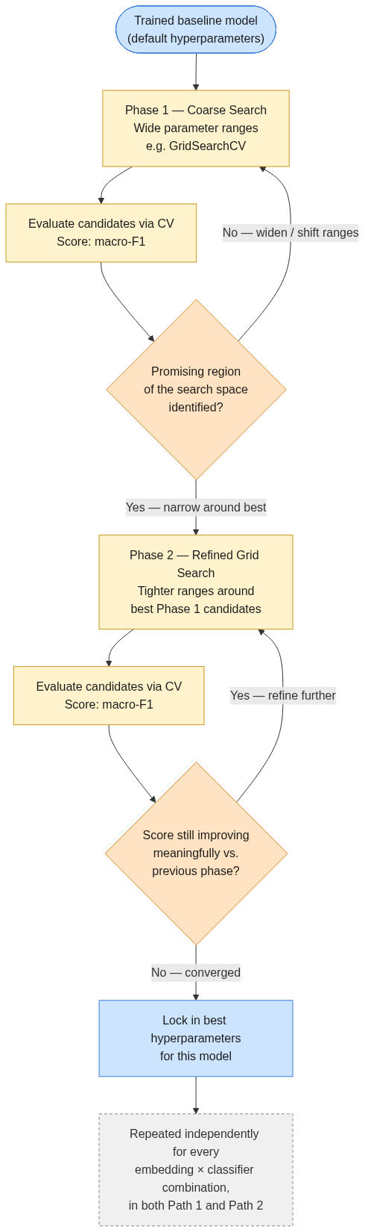
5.5 Hyperparameter Optimization
To maximize predictive performance, each classifier underwent systematic hyperparameter optimization using an iterative GridSearchCV procedure. Hyperparameter tuning followed a two-stage process consisting of an initial coarse search over a wide parameter space, followed by progressively narrower searches centered around the best-performing parameter combinations identified during previous iterations.
Model performance during optimization was evaluated using cross-validation with the macro F1-score as the optimization metric. This evaluation strategy ensured balanced performance across all classes, regardless of class size, thereby reducing the influence of class imbalance on model selection. The optimization process was repeated independently for every combination of feature representation and classifier across both classification pathways.

5.6 Model Evaluation
The trained models were evaluated using multiple complementary performance metrics to provide a comprehensive assessment of classification effectiveness. These included precision, recall, macro F1-score, and confusion matrices. Precision measured the proportion of correctly predicted instances among all predictions for a given class, while recall quantified the proportion of actual instances correctly identified by the classifier. The macro F1-score was selected as the primary evaluation metric because it equally weights the performance of each class and therefore provides a more balanced assessment in the presence of class imbalance.
Confusion matrices were generated to visualize patterns of correct and incorrect predictions across the different medical specialties and super-classes. In addition, cross-validation was performed throughout model development to estimate the generalization performance of each classifier and reduce the risk of overfitting.

5.7 Dimensionality Reduction and Visualization
To better understand the structure of the extracted text features, dimensionality reduction techniques were employed for visualization. Principal Component Analysis (PCA) was used to project the high-dimensional feature representations onto two principal components while preserving as much variance as possible. Additionally, t-distributed Stochastic Neighbor Embedding (t-SNE) was applied to visualize local relationships between clinical documents in a two-dimensional space.
These visualization techniques provided qualitative insight into the separability of the medical specialties and super-classes. The resulting plots were used to investigate whether naturally occurring clusters existed within the clinical text and to support interpretation of the classification results obtained by the machine learning models.
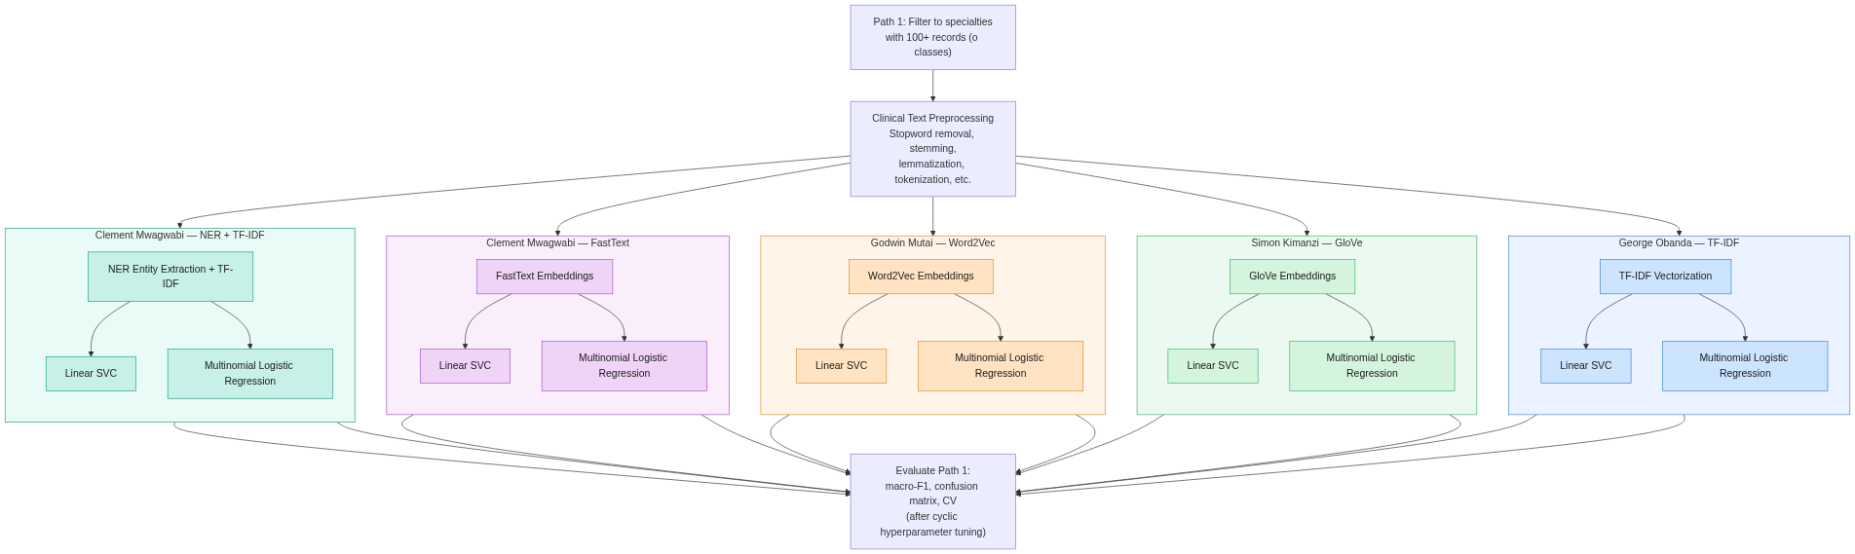
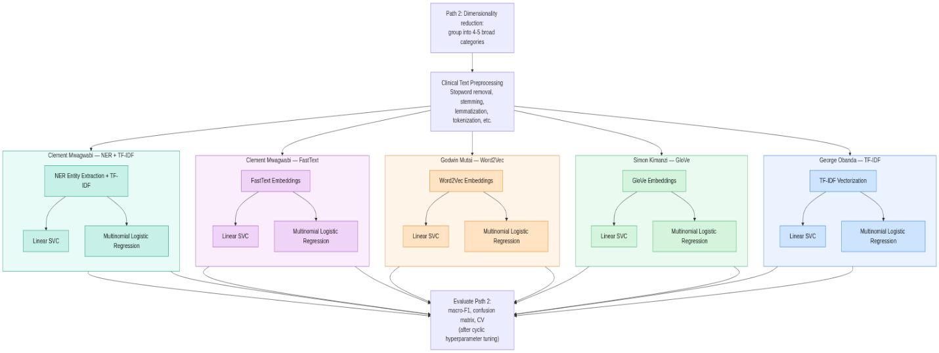

6. Results and Discussion

6.1 Dataset Exploration
The initial exploratory analysis revealed that the MTSamples dataset consisted of 4,999 de-identified clinical transcription records distributed across 40 medical specialties. Examination of the class distribution showed substantial class imbalance, with a small number of specialties containing a large proportion of the available transcripts while many specialties were represented by relatively few records. Such imbalance presents a major challenge for supervised machine learning because classifiers tend to favor majority classes during training, often resulting in reduced performance on underrepresented specialties.
To investigate the impact of this imbalance, two complementary classification pathways were developed. The first pathway focused on the nine medical specialties that contained at least 100 clinical transcripts, thereby retaining fine-grained specialty prediction while reducing extreme imbalance. The second pathway grouped the original specialties into five broader clinical super-classes, increasing the number of training examples available within each class and simplifying the classification problem. These two pathways enabled direct comparison between maintaining detailed specialty information and reducing classification complexity through broader clinical categorization.

6.2 Model Performance Comparison
Comparison of the trained models demonstrated that TF-IDF consistently outperformed the alternative feature representation techniques across both classification pathways. Although modern embedding methods such as Word2Vec, GloVe, and FastText are capable of capturing semantic relationships between words, they did not surpass the simpler TF-IDF representation on this dataset. The superior performance of TF-IDF suggests that the frequency and uniqueness of clinical terminology were more informative for specialty prediction than the semantic relationships learned by the embedding methods.
Among the evaluated classifiers, the combination of TF-IDF and Multinomial Logistic Regression produced the best overall performance and was therefore selected as the final model for further analysis. This finding demonstrates that relatively simple linear models remain highly competitive for many clinical text classification tasks when combined with effective feature engineering and appropriate hyperparameter optimization.

6.3 Feature Space Visualization
To better understand the separability of the clinical documents, dimensionality reduction techniques were applied to the feature representations. Principal Component Analysis (PCA) and t-distributed Stochastic Neighbor Embedding (t-SNE) were used to project the high-dimensional TF-IDF vectors into two-dimensional space for visual inspection.
The PCA analysis showed limited separation between the clinical classes, with considerable overlap observed among the projected data points. This indicates that the first two principal components captured only a small proportion of the variability required to distinguish between medical specialties. The overlapping distributions suggest that many specialties share common vocabulary and clinical terminology, making linear separation difficult using low-dimensional projections.
Similarly, the t-SNE visualizations demonstrated that although some local grouping of related clinical documents existed, substantial overlap remained between several classes. The observed clustering patterns support the hypothesis that clinical narratives frequently contain similar symptoms, diagnostic procedures, and treatment descriptions across multiple specialties. Consequently, distinguishing between specialties based solely on textual information remains a challenging classification problem.
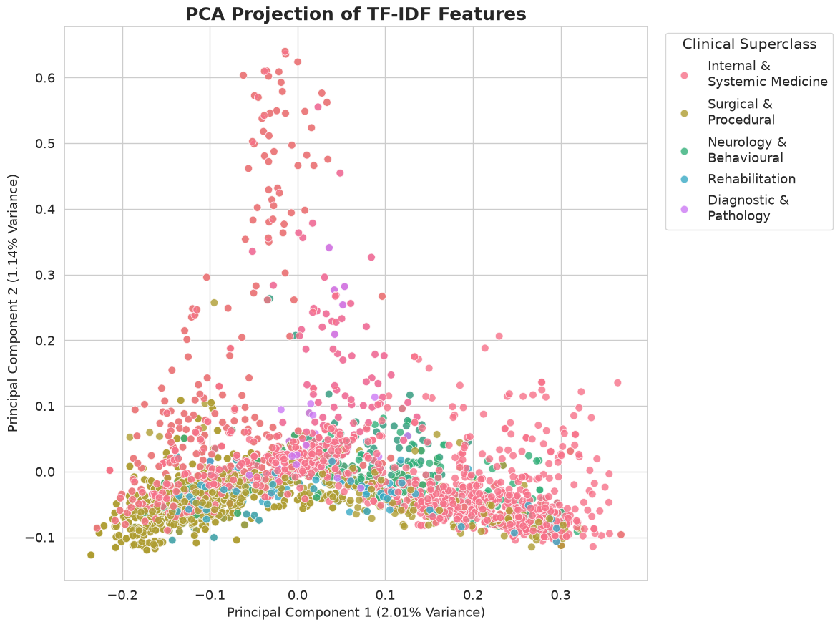

6.4 Evaluation of the Best Performing Model
The best-performing model, consisting of TF-IDF feature representation and Multinomial Logistic Regression, achieved a Macro F1-score of 0.62. The use of the macro F1-score as the primary evaluation metric provided a balanced assessment of model performance across all classes by giving equal importance to majority and minority categories. Although this score indicates that the model successfully learned meaningful relationships within the clinical text, it also demonstrates that considerable room for improvement remains before the model can be considered sufficiently reliable for deployment in clinical environments.
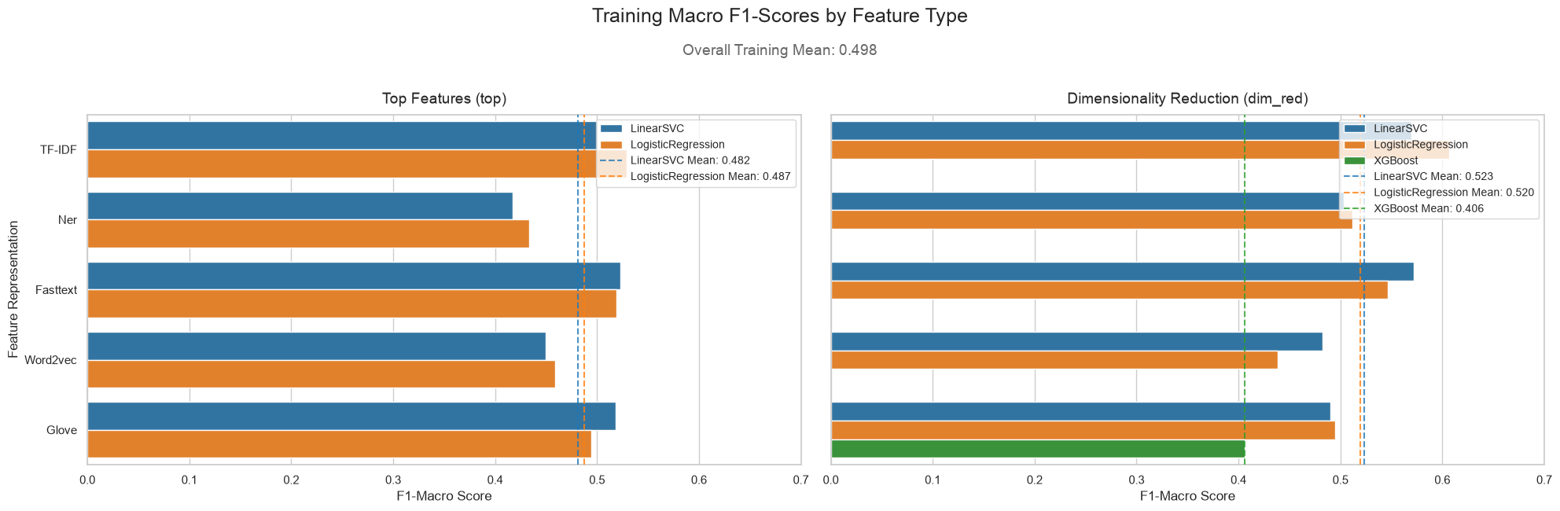
Confusion matrix analysis revealed that some clinical categories were classified with greater accuracy than others. Classes characterized by distinctive terminology and specialized procedures tended to achieve higher predictive performance, whereas specialties sharing similar clinical language exhibited greater levels of misclassification. These findings are consistent with the overlapping feature distributions observed in the dimensionality reduction analyses.
Further insight was obtained through precision, recall, and macro F1-score visualizations. The bubble chart and metric heatmap illustrated variations in classifier performance across the different clinical super-classes, demonstrating that prediction quality was not uniform across all categories.
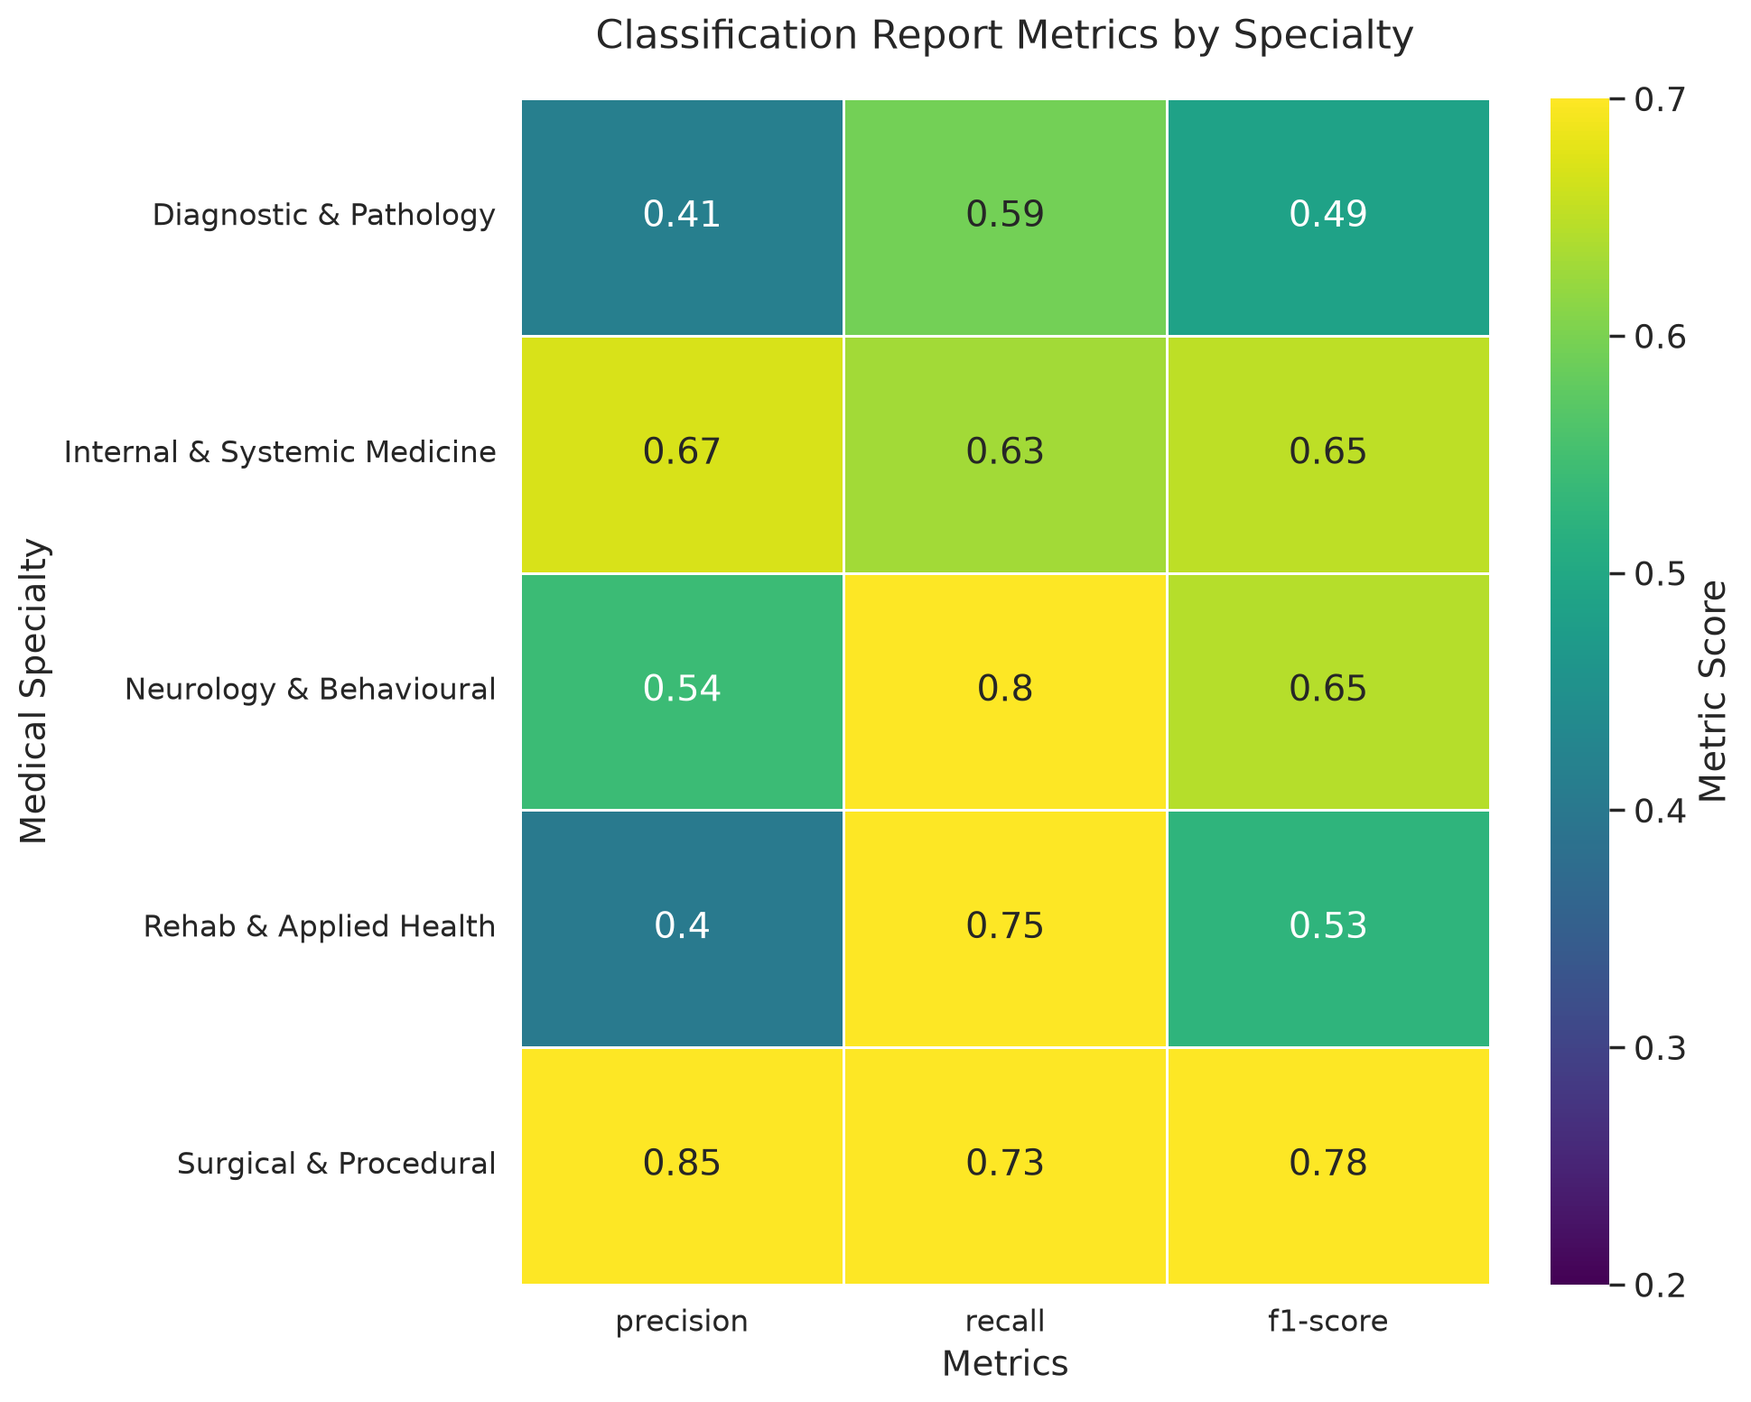
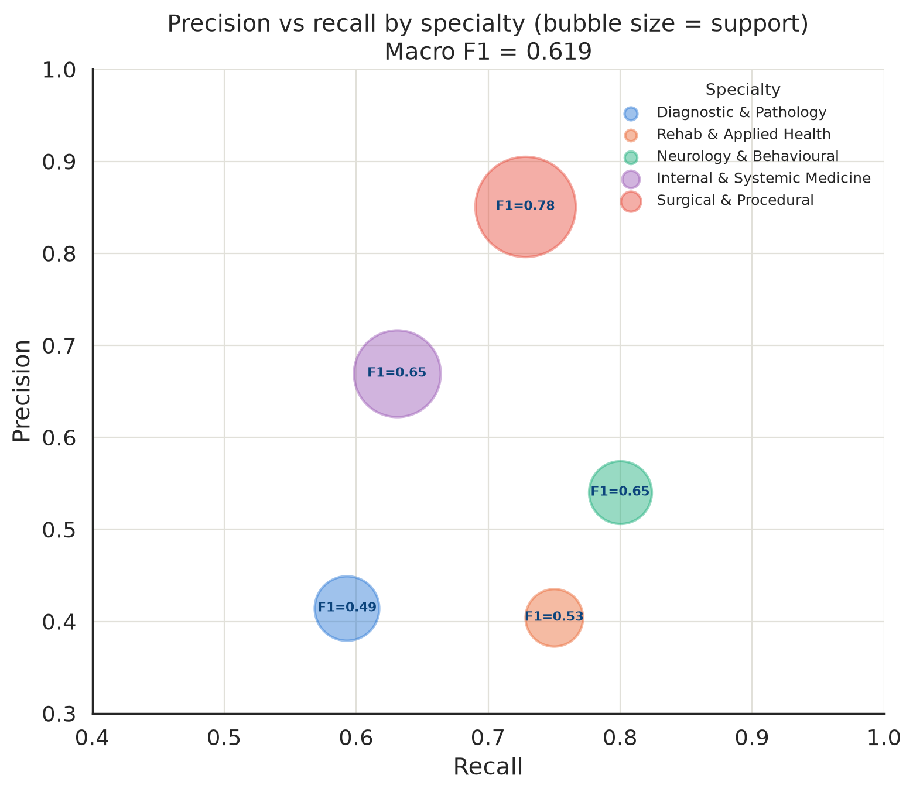

6.5 Discussion of Findings
The results of this project demonstrate that classical machine learning methods remain effective baseline approaches for clinical text classification despite the increasing popularity of transformer-based language models. The superior performance of TF-IDF suggests that document-specific medical terminology provides strong discriminative information for specialty prediction, particularly when combined with a linear classifier such as Multinomial Logistic Regression.
Nevertheless, the moderate Macro F1-score obtained by the best-performing model highlights the inherent complexity of clinical language. Medical specialties frequently share overlapping symptoms, diagnostic terminology, laboratory investigations, and treatment procedures, making it difficult for traditional machine learning algorithms to distinguish between related clinical disciplines. Furthermore, the substantial class imbalance present within the original dataset
contributed additional challenges by limiting the amount of training data available for several specialties.
The comparison between the two classification pathways further demonstrated the trade-off between classification granularity and predictive robustness. Restricting the analysis to the most common specialties preserved detailed clinical predictions but reduced the amount of available training data. Conversely, grouping specialties into broader clinical super-classes increased class representation and simplified the classification task, although at the expense of specialty-level specificity. These complementary approaches provided valuable insight into how class structure influences machine learning performance in clinical text mining applications.
Overall, the findings indicate that classical machine learning provides a useful baseline for clinical specialty prediction but is unlikely to achieve the level of accuracy required for routine clinical decision support without more advanced language models capable of capturing richer contextual information.

7. Limitations of the Project
Although this project successfully demonstrated the application of classical machine learning techniques for clinical text classification, several limitations should be considered when interpreting the findings.
The first limitation relates to the dataset itself. Although the MTSamples dataset contains nearly 5,000 clinical transcription records, the data are distributed across 40 medical specialties, resulting in substantial class imbalance. Many specialties contain relatively few examples compared to others, making it difficult for supervised learning algorithms to adequately learn the characteristics of minority classes. This imbalance motivated the development of the two classification pathways investigated in this project, but it remains an inherent challenge that affected overall model performance.
A second limitation concerns the similarity of language used across different medical specialties. Clinical narratives often describe common symptoms, diagnostic procedures, laboratory investigations, and treatment plans that are shared among multiple disciplines. Consequently, transcripts originating from different specialties may contain highly overlapping vocabulary, reducing the discriminative power of traditional text representation techniques. This overlap was evident in the dimensionality reduction analyses, where PCA and t-SNE visualizations demonstrated limited separation between several clinical categories.
Another limitation is the exclusive use of classical machine learning algorithms. While TF-IDF, Word2Vec, GloVe, FastText, and NER-based representations provide effective baseline approaches for text classification, these methods primarily rely on word frequency statistics or static word embeddings. They are generally less capable of capturing contextual meaning and long-range semantic relationships than modern transformer-based language models. As a result, the models investigated in this project may not fully exploit the rich contextual information contained within clinical narratives.
In addition, the project focused on evaluating only two linear classification algorithms, namely Linear Support Vector Classification (Linear SVC) and Multinomial Logistic Regression. Although these classifiers have demonstrated strong performance in many text classification tasks, alternative machine learning methods and deep learning architectures may provide improved predictive capability when applied to clinical text.

8. Conclusion and Future Work
Among the evaluated approaches, the combination of TF-IDF and Multinomial Logistic Regression achieved the best overall performance, obtaining a Macro F1-score of 0.62. Although this demonstrates that classical machine learning techniques can successfully learn meaningful patterns from clinical text, the moderate performance and overlapping feature distributions indicate that clinical specialty prediction remains a challenging problem due to shared medical terminology and class imbalance. Consequently, the developed models should be regarded as strong baseline classifiers rather than systems ready for deployment in clinical practice.
Future research should investigate the use of transformer-based language models, such as BERT-based architectures, which are capable of capturing richer contextual representations of clinical language than traditional machine learning methods. In addition, expanding the dataset, improving class balance, incorporating domain-specific medical embeddings, and exploring ensemble learning approaches may further improve classification performance. These directions have the potential to produce more accurate and robust clinical text classification systems capable of supporting healthcare professionals in clinical decision-making and patient referral processes.

